- REST API with GET /api/Products .This endpoint retrieves a list of all Products records currently stored in MongoDb Database.
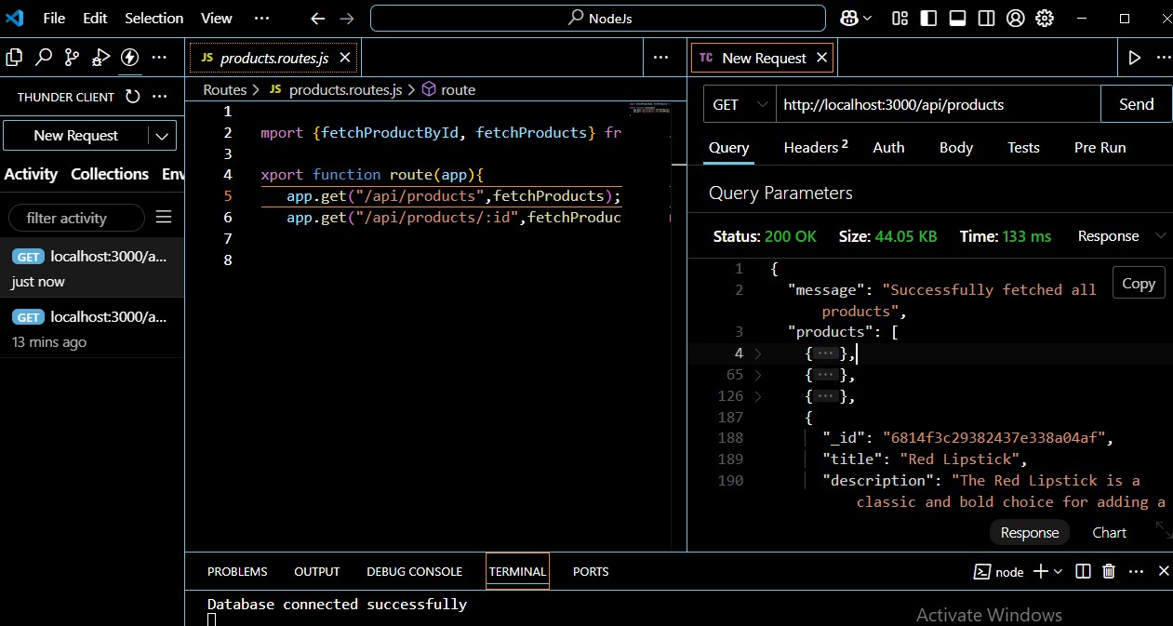

- Screenshot: MongoDB Compass showing results after GET API execution
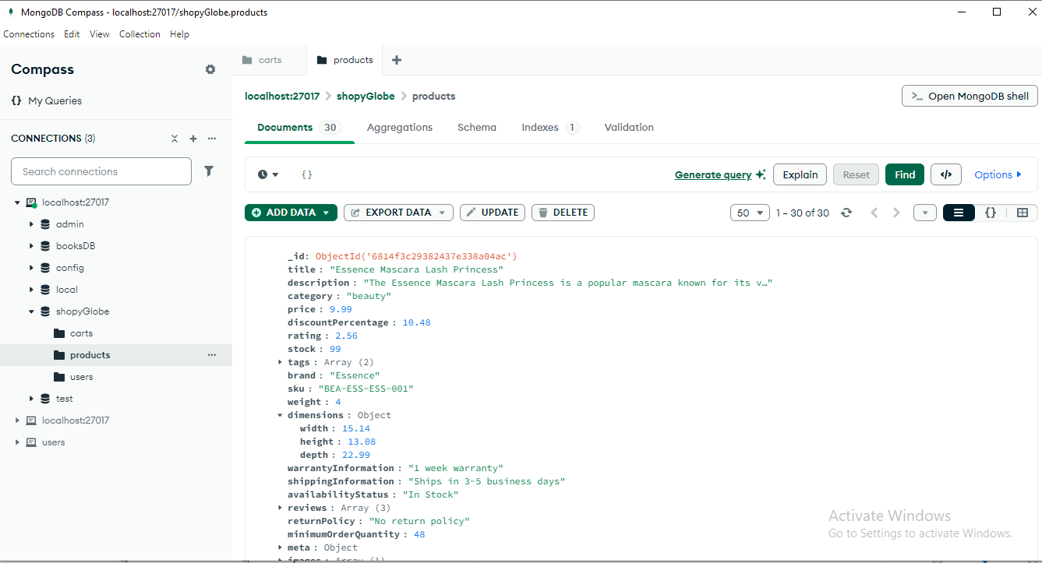

- REST API with GET /api/Products/:Id .This endpoint retrieves a Specific Product by id from MongoDb Database.

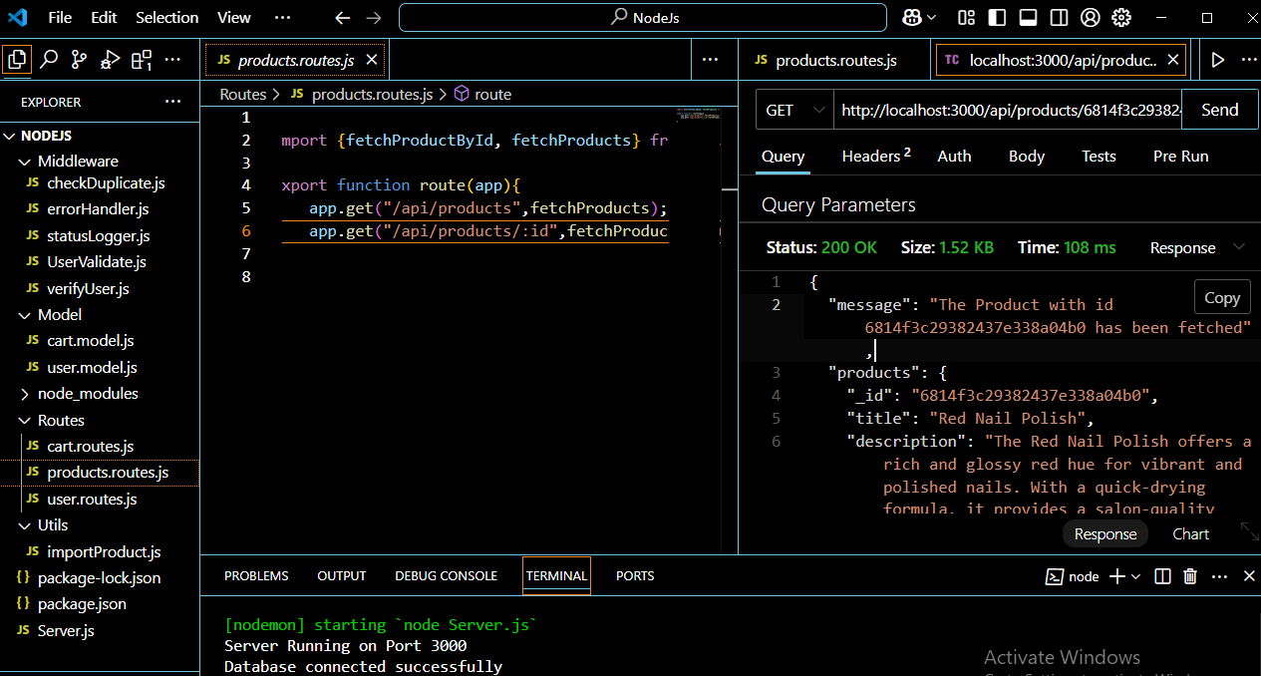

- Screenshot: MongoDB Compass showing results after GET /api/products/:Id API execution
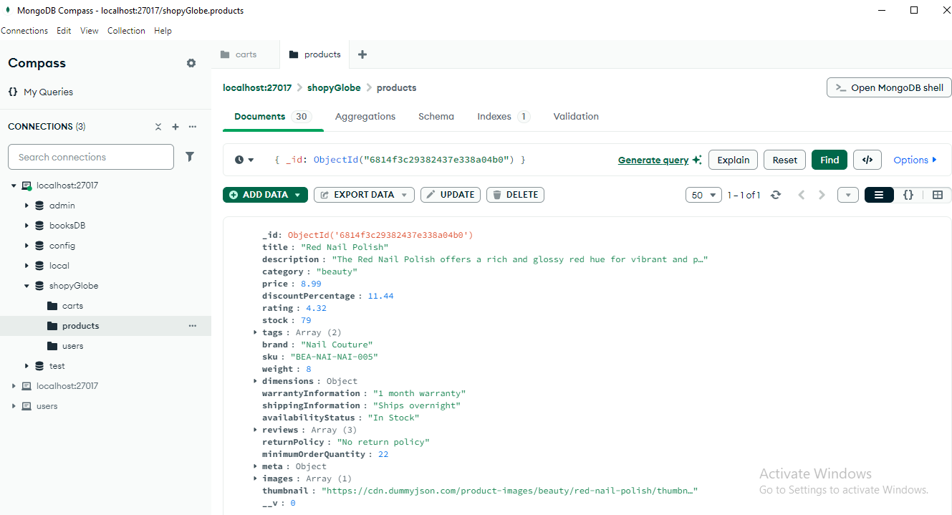

- REST API with POST/api/cart/.This endpoint Add Products to the cart collection of MongoDb Database.

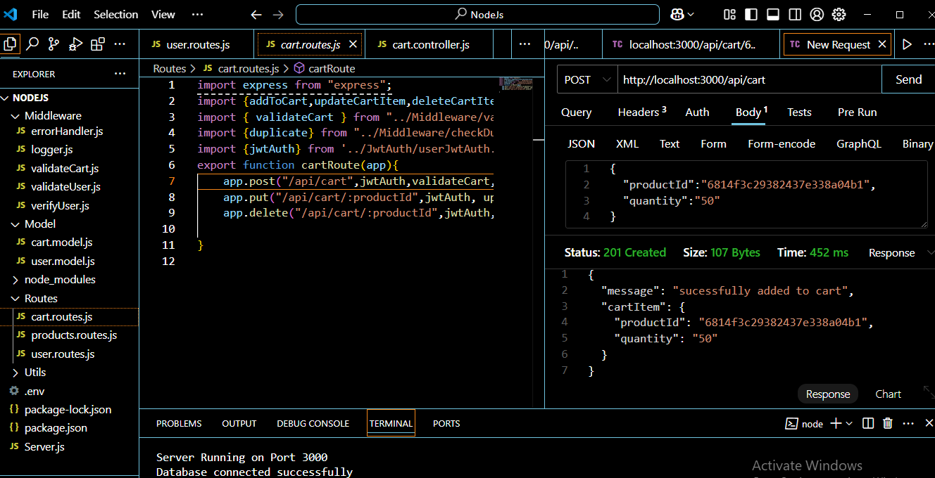

- Screenshot: MongoDB Compass showing results after POST /api/cart/ API execution
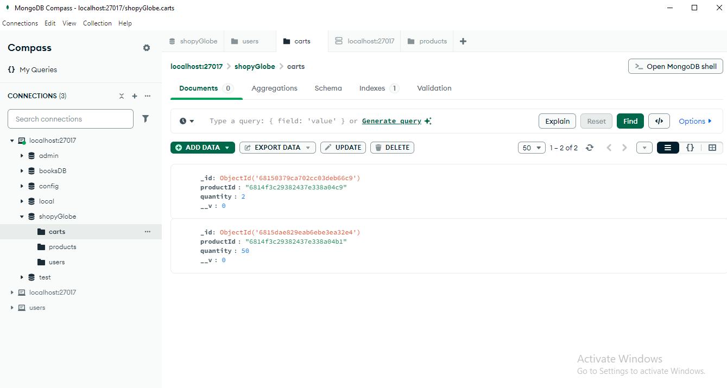

- REST API with PUT/api/cart/:id.This endpoint Update CartItem
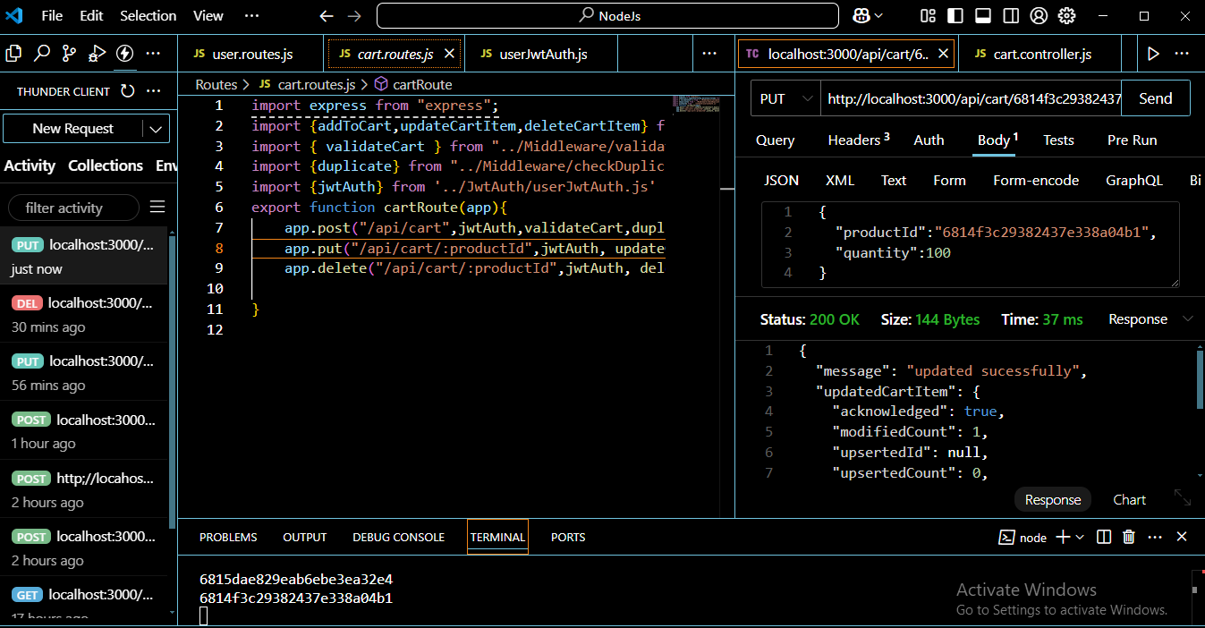
- Screenshot: MongoDB Compass showing results after PUT/api/cart/:id API execution
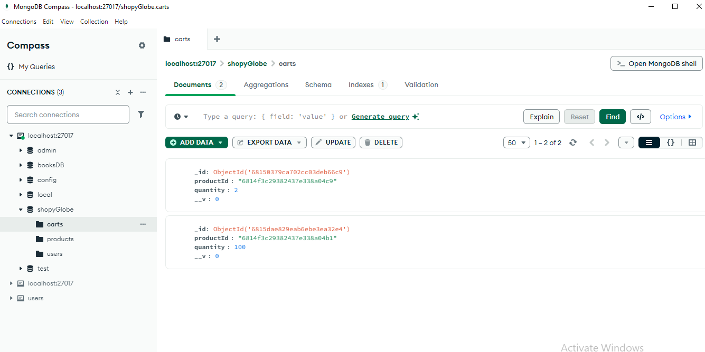

- REST API with DELETE/api/cart/:id.This endpoint Delete cartItem from MongoDb Database.

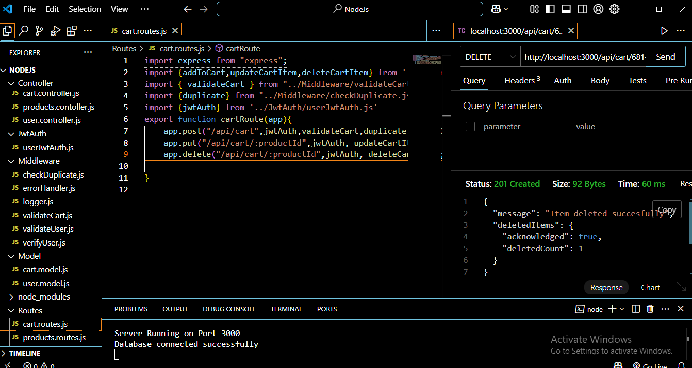
- Screenshot: MongoDB Compass showing results after DELETE/api/cart/:id API execution
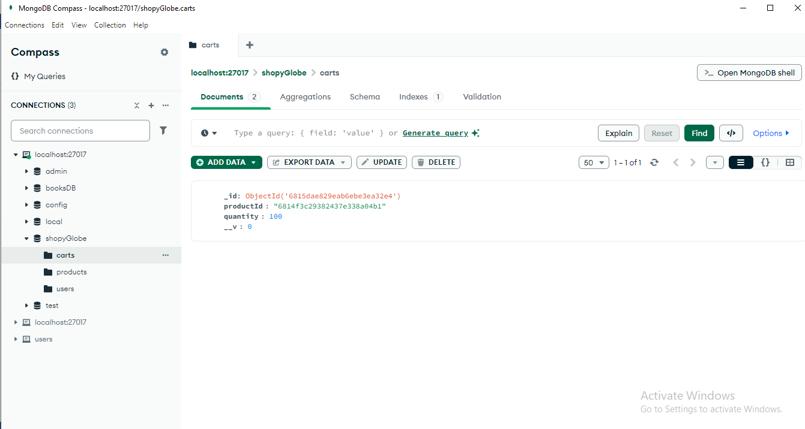

- Error Handling for Api Routes:
- Cart Validation : Validate input data for required field
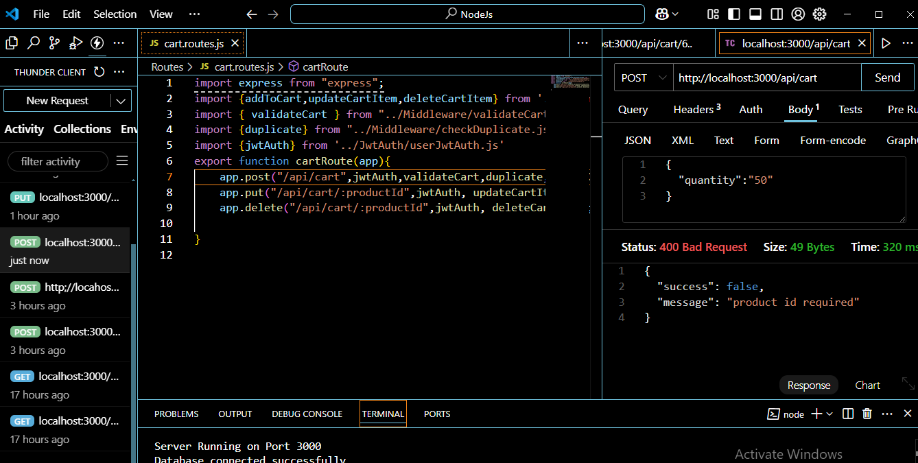
- Validate input data : Check if product ID exists before adding to cart
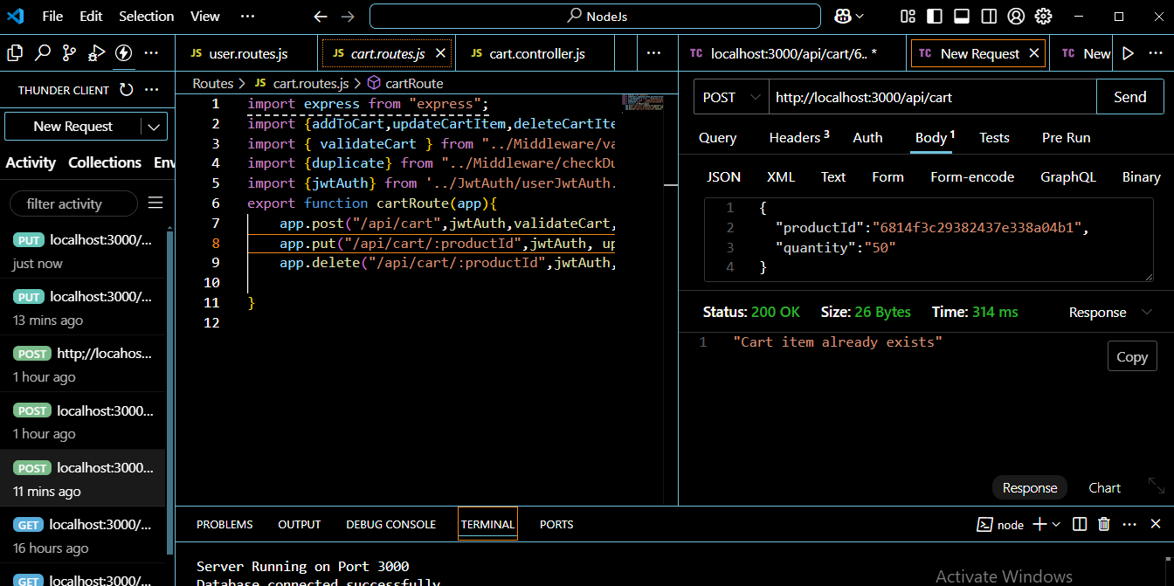
- Authorisation Check: Unauthorised User cannot update and Delete the cartItem
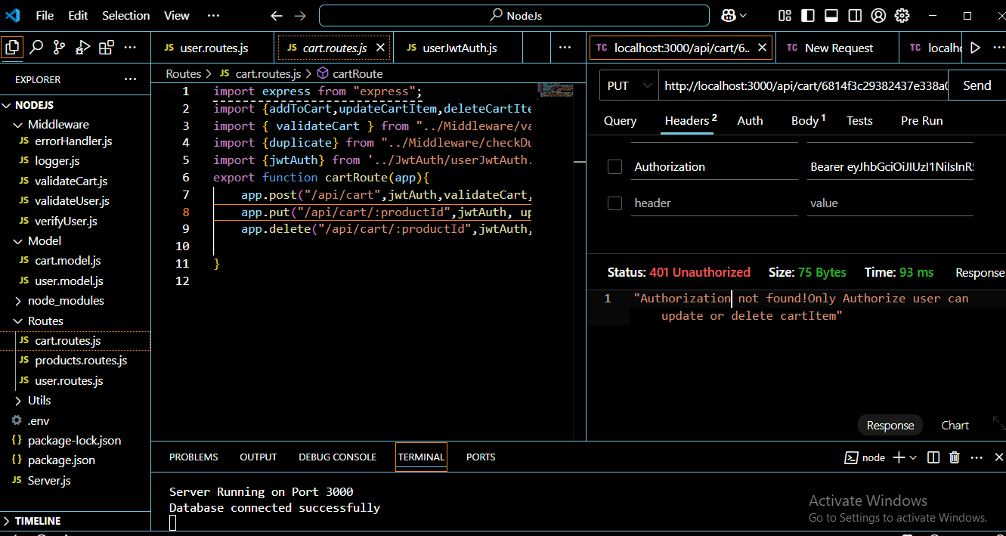

- REST API with POST/api/register/.This endpoint Add User into the user collection of MongoDb Database.
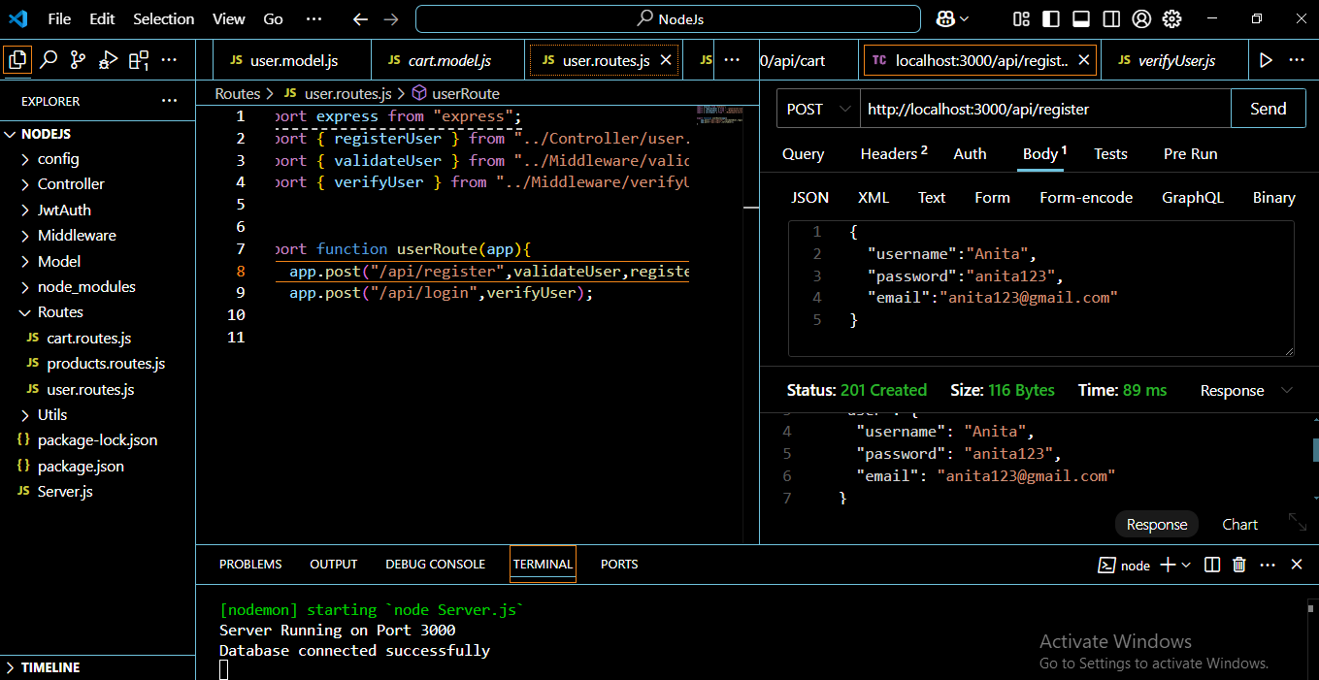

- Screenshot: MongoDB Compass showing results after Post/api/register API execution

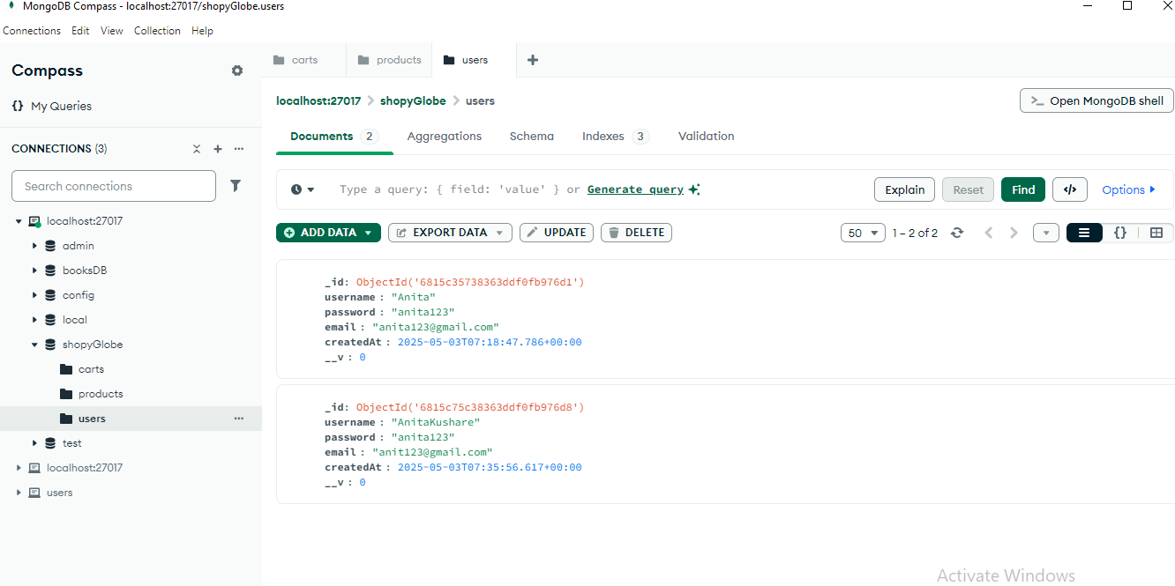

- REST API with POST/api/login/.This endpoint login user and generate jwt token
